Chapter 10, Problem 80.

Obtain v_{o}(t) for the op amp circuit in Fig. 10.123 if v_{s} = 4 cos (1000t - 60°) V.

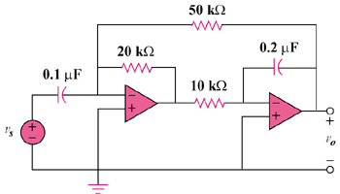

Figure 10.123
For Prob. 10.80.

